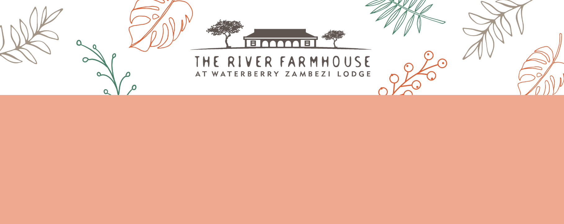

FACT SHEET

The River Farmhouse is a private safari house for groups four to ten guests. With larger groups additional guests sleep in the Lodge or The Woodlands and spend the day at the Farmhouse. The Farmhouse has beautifully tended gardens, infinity swimming pool and views over the Zambezi River to the national park beyond.

**Guests at River Farmhouse enjoy the services of a private chef, waiting, household and garden staff, together with private boat and vehicles.**

# ALL BEDROOMS HAVE:

* + Super king or large single beds
  + Air conditioning
  + Ceiling fan
  + Mosquito net
  + Electric blanket
  + Ensuite shower or bath room with towels, face flannels, bath robes, hair dryer, toiletries
  + Shelves and hanging rails for storage, plus luggage stands
  + Drinking water
  + Mosquito repellent
  + Hand sanitizer
  + Electricity (220v square 3-pin, adaptors available)
  + Wi-Fi
  + Personal waiter service throughout the day for tea, coffee and other drinks
  + Laundry basket for complimentary daily laundry service

|  |  |  |  |  |
| --- | --- | --- | --- | --- |
| NAME | ROOM TYPE | BED SIZE | SLEEPS | FEATURES |
| North | Double | 183cm/6ft 0 in | 2 | French windows open onto the veranda with a view to the Zambezi. Ensuite bathroom with bath and shower. |
| East | Double | 183cm/6ft 0in | 2 | French windows open onto the veranda with a view to the Zambezi. Ensuite bathroom with bath and shower. |
| South | Twin or Double | 2 x 107cm/3ft 6in OR 1 x 214cm/7ft 0in | 2 | Windows overlook the gardens. The beds can be put together to make a double. Ensuite shower room. |
| West Suite | Room 1:  Twin or Double | 2 x 107cm/3ft 6in OR 1 x 214cm/7ft 0in | 2 | Windows overlook the gardens, beds can be twin or double.  Share shower room with West Suite Room 2. Can take an extra  single bed. |
| Room 2:  Twin or Double | 2 x 107cm/3ft 6in OR 1 x 214cm/7ft 0in | 2 | Window overlooks the garden, beds can be twin or double.  Share shower room with West  Suite Room 1. |

**Waterberry Zambezi Lodge**

**January 2025**